|  |
| --- |
| CSR Generation: Microsoft IIS 7.x |
| * Click **Start.** * Select **Administrative Tools.** * Start **Internet Services Manager.** * Click **Server Name.** * From the center menu, double-click the **"Server Certificates"** button in the **"Security"** section.   https://support.comodo.com/uploaded/ssl-IIS1.JPG   * Select **"Actions"** menu (on the right), click on **"Create Certificate Request."**   https://support.comodo.com/uploaded/ssl-IIS2.JPG   * This will open the **Request Certificate** wizard.   https://support.comodo.com/uploaded/ssl-IIS3.JPG   * In the **"Distinguished Name Properties"** window, enter the information as follows: * The **Common Name** field should be the **Fully Qualified Domain Name** (FQDN) or the web address for which you plan to use your IIS SSL Certificate. You will need to insure that the common name submitted in the CSR is the correct domain name / FQDN that you intend to use the certificate for. For wildcard SSL certificates the common name should contain at least one asterisks **(*)** e.g. *.comodo.com,*.instantssl.com,etc * Enter **Organisation** and **Organisation Unit**, these are your company name and department respectively. * Enter your **City/locality**, **State/province** and **Country/region.** * Click **Next.** * In the **"Cryptographic Service Provider Properties"** window, Leave Cryptographic Service provider Default (Microsoft RSA SChannel Cryptographic Provider) Change the Bit Length to (2048) then Click **Next.**   SetKeySizeAndCSP   * Enter a filename and location to save your CSR. You will need this CSR to enroll for your IIS SSL Certificate.   https://support.comodo.com/uploaded/ssl-IIS5.JPG   * Click **Finish.** * Your new CSR is now contained within the file **c:\certreq.txt** * When you make your application, make sure you include the CSR in its entirety into the appropriate section of the enrollment form - including  **-----BEGIN CERTIFICATE REQUEST-----to-----END CERTIFICATE REQUEST-----** * Click **Next** * Confirm your details in the enrollment form * Finish   **To save your private key:**   * Go to: **Certificates** snap in in the MMC * Select **Requests** * Select **All tasks** * Select **Export**   We recommend that you make a note of your password and backup your key as these are known only to you, so if you loose them we can't help! A floppy diskette or other removable media is recommended for your backup files. ** please note that this last step is not required but is recommended if you intend to make any changes to the site. |

IIS7中SSL证书安装指南

1.启动Internet（IIS）服务器：  
开始>程序管理工具>Internet信息服务器管理（IIS）  
2.选择菜单栏左边部分的Connections菜单  
  
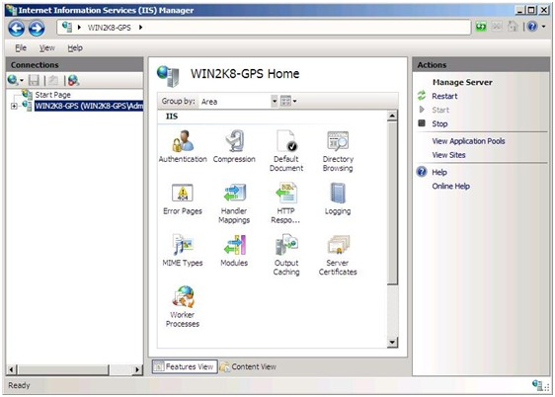  
3.双击IIS管理器窗口中中间的服务器证书菜单，打开服务器证书特点。  
4.选择右边完成证书申请选项，启动完成证书申请向导  
  
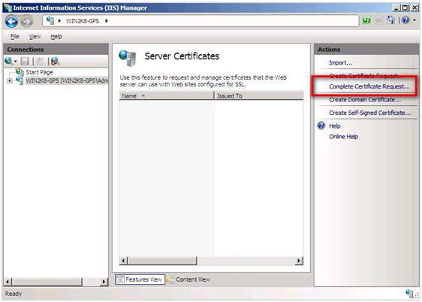  
5.找到后缀为.cer的证书文件。输入一个证书的名字，此名称不会出现在证书中，只是为了管理员使用跟踪的。  
  
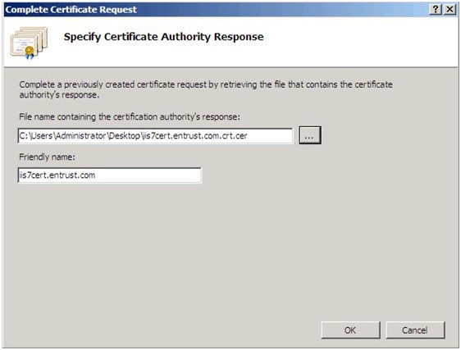  
6.单击确定，显示证书正在安装  
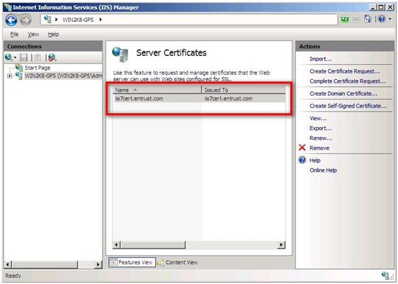  
双击打开安装的证书。在常规选项中，您将看到CA颁发给该证书的字段名称。选择证书路径选项，注意要确认您的CA发行人的证书已经安装（如Entrust根证书）。如果没有要在你自己的服务器上安装证书链。  
注：确保安装正确的证书链  
将你的网站添加到新安装的SSL证书IIS7服务器中：  
1.在IIS中，在左侧菜单显示的网站中选择你的网站，选择绑定  
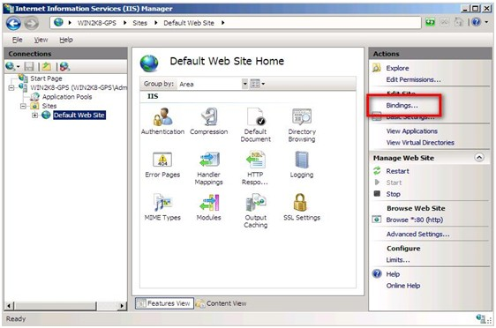  
2.从窗口中选择要添加的网站，如果HTTPS已经在列表中，选择并编辑，会出现一窗口  
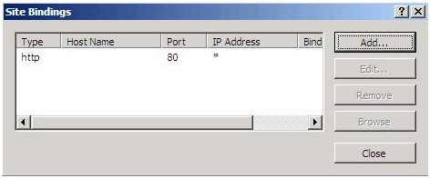  
3.在添加网站绑定窗口中，设置类型为HTTPS，IP地址为All Unassigned，端口为443，选择正确的SSL证书，点击确认  
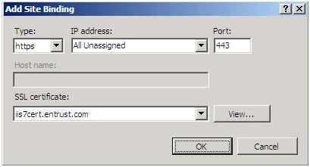  
4.在网站绑定窗口中，会显示新添加的网站，单击“关闭”  
